Instructions for Making Work Style Ratings

These questions are about work styles. A Work Style is a personal characteristic that can affect how well someone does a job. You will be asked about a series of different work styles and how they relate to your current job – that is, the job you hold now.

First, each work style is named and defined. For example:

Stress Tolerance | Job requires accepting criticism and dealing calmly and effectively with high-stress situations.

Then you are asked How important is this characteristic to the performance of your current job? For example:

How important is STRESS TOLERANCE to the performance of your current job?

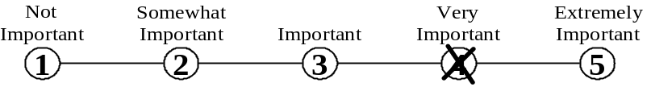

Mark your answer by putting an X through the number that represents your answer.
Do not mark on the line between the numbers.

1. Achievement/Effort | Job requires establishing and maintaining personally challenging achievement goals and exerting effort toward mastering tasks.

How important is ACHIEVEMENT/EFFORT to the performance of your current job?

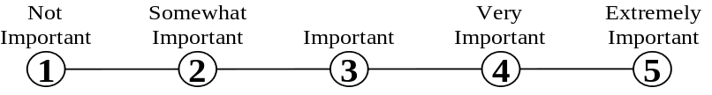

2. Persistence | Job requires persistence in the face of obstacles.

How important is PERSISTENCE to the performance of your current job?

3. Initiative | Job requires a willingness to take on responsibilities and challenges.

How important is INITIATIVE to the performance of your current job?

4. Leadership | Job requires a willingness to lead, take charge, and offer opinions and direction.

How important is LEADERSHIP to the performance of your current job?

5. Cooperation | Job requires being pleasant with others on the job and displaying a good-natured, cooperative attitude.

How important is COOPERATION to the performance of your current job?

6. Concern for Others | Job requires being sensitive to others' needs and feelings, and being understanding and helpful to others on the job.

How important is CONCERN FOR OTHERS to the performance of your current job?

7. Social Orientation | Job requires preferring to work with others rather than alone, and being personally connected with others on the job.

How important is SOCIAL ORIENTATION to the performance of your current job?

8. Self-Control | Job requires maintaining composure, keeping emotions in check, controlling anger, and avoiding aggressive behavior, even in very difficult situations.

How important is SELF-CONTROL to the performance of your current job?

9. Stress Tolerance | Job requires accepting criticism and dealing calmly and effectively with high-stress situations.

How important is STRESS TOLERANCE to the performance of your current job?

10. Adaptability/Flexibility | Job requires being open to change (positive or negative) and to considerable variety in the workplace.

How important is ADAPTABILITY/FLEXIBILITY to the performance of your current job?

11. Dependability | Job requires being reliable, responsible, and dependable, and fulfilling obligations.

How important is DEPENDABILITY to the performance of your current job?

12. Attention to Detail | Job requires being careful about details and thorough in completing tasks.

How important is ATTENTION TO DETAIL to the performance of your current job?

13. Integrity | Job requires being honest and ethical.

How important is INTEGRITY to the performance of your current job?

14. Independence | Job requires developing one's own ways of doing things, guiding oneself with little or no supervision, and depending on oneself to get things done.

How important is INDEPENDENCE to the performance of your current job?

15. Innovation | Job requires creativity and alternative thinking to develop new ideas for and answers to work-related problems.

How important is INNOVATION to the performance of your current job?

16. Analytical Thinking | Job requires analyzing information and using logic to address work-related issues and problems.

How important is ANALYTICAL THINKING to the performance of your current job?

